**Code**

1. public int[] test(int m, int d, int y){
2. int[] mdy = {m,d,y};
3. if((m == 1)||(m == 3)||(m == 5)||(m == 7)||(m == 8)||(m == 10)){
4. if(d < 31){
5. mdy[1] = d + 1;

}

1. else{

mdy[0] = m + 1;

mdy[1] = 1;

}

1. }
2. else if((m == 4)||(m == 6)||(m == 9)||(m == 11)){
3. if(d < 30){
4. mdy[1] = d + 1;

}

1. else{

mdy[0] = m + 1;

mdy[1] = 5;

}

1. }
2. else if(m == 12){
3. if(d < 31){
4. mdy[1] = d + 1;

}

1. else{

mdy[0] = 1;

mdy[1] = 1;

mdy[2] = y + 1;

}

1. }
2. else{
3. if(d < 28){
4. mdy[1] = d + 1;

}

1. else if(d == 28){
2. if((y % 4 == 0 && y % 100 != 0) || y % 400 == 0){
3. mdy[1] = d + 1;

}

1. else{

mdy[0] = m+1;

mdy[1] = 1;

}

1. }
2. else{

mdy[0] = m+1;

mdy[1] = 1;

}

1. }
2. return mdy;
3. }

**Graph**

**C1: Cover Every DD-Path**

**Model**

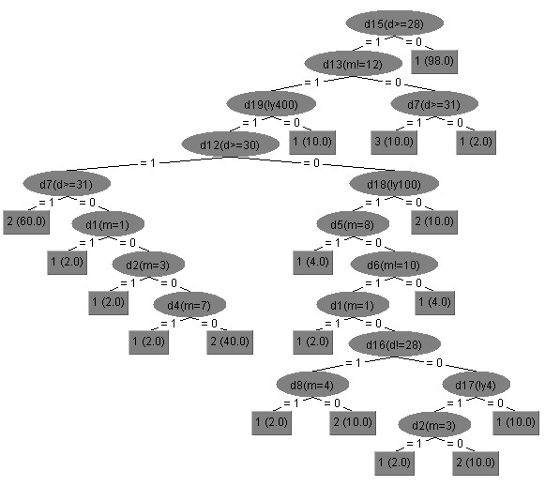

|  |  |  |  |  |  |
| --- | --- | --- | --- | --- | --- |
|  | | DD-Path Coverage | Input | Output(code) | Output(model) |
| 1 | P1 | 1,2,3,4,5,7,28,29 | 03 22 2011 | 03 23 2011 | 03 23 2011 |
| P2 | 1,2,3,4,6,7,28,29 | 03 31 1937 | 04 01 1937 | 04 01 1937 |
| P3 | 1,2,3,8,9,10,12,28,29 | 04 22 1943 | 04 23 1943 | 04 23 1943 |
| P4 | 1,2,3,8,9,11,12,28,29 | 04 30 2001 | 05 05 2001 | 05 01 2001 |
| P5 | 1,2,3,8,13,14,15,17,28,29 |  |  |  |
| P6 | 1,2,3,8,13,14,16,17,28,29 |  |  |  |
| P7 | 1,2,3,8,13,18,19,20,27,28,29 |  |  |  |
| P8 | 1,2,3,8,13,18,19,21,22,23,25,27,28,29 |  |  |  |
| P9 | 1,2,3,8,13,18,19,21,22,24,25,27,28,29 |  |  |  |
| P10 | 1,2,3,8,13,18,19,21,26,27,28,29 |  |  |  |